National Council of State Agencies for the Blind

An Update on Services and Outcomes of Blind and Visually Impaired Consumers Served in Separate and General/Combined VR Agencies

Rehabilitation Research and Training Center  on Blindness & Low Vision  College of Education |  | 

National Council of State Agencies for the Blind

An Update on Services and Outcomes of Blind and Visually Impaired Consumers Served in Separate and General/Combined VR Agencies

Prepared by:
Brenda Cavenaugh, Ph.D., CRC

March 2010

This research was conducted by the Rehabilitation Research and Training Center (RRTC) on Blindness and Low Vision under a contract from the National Council of State Agencies for the Blind, Inc., 4733 Bethesda Avenue, Suite 330, Bethesda, MD 20814.

Mississippi State University
RRTC on Blindness and Low Vision
P. O. Box 6189
Mississippi State University, MS 39762
Phone: 662-325-2001
http://www.blind.msstate.edu

An Update on Services and Outcomes of Blind and Visually Impaired Consumers Served in Separate and General/Combined VR Agencies

Background

The Barden-LaFollette Act of 1942 specifically provided that any State with a legally constituted commission or agency for the blind could assign to it the administration of the federal-state vocational rehabilitation (VR) program serving individuals who are blind or visually impaired. Although the merits of these separate state agencies have been debated throughout the history of the state-federal program, during the late 1990s disability groups favoring a general or cross-disability model of services were especially vocal in advocating that the Rehabilitation Service Administration (RSA) discontinue funding of separate VR agencies. In response, the Rehabilitation Research and Training Center (RRTC) on Blindness and Low Vision at Mississippi State University initiated studies to investigate relationships between VR agency structure and services and outcomes of blind and visually impaired consumers. A comprehensive review of the literature plus analyses of the latest available RSA-911 data were conducted to investigate relationships. Research findings indicated that separate blindness agencies, when compared to general/combined agencies, serve a higher percentage of consumers with socio-demographic characteristics associated with lower labor force participation rates and further, that competitive placement rates and weekly earnings at closure are also higher in separate agencies (Cavenaugh & Pierce, 1998; Cavenaugh, 1999; Cavenaugh, Giesen, & Pierce, 2000).

Purpose

Recent economic downturns have resulted in some state governments with separate VR agencies again considering the economic benefits of consolidating VR services into one combined agency serving all individuals with disabilities. Currently 24 states have a separate VR agency or commission that provides services exclusively for consumers who are blind or visually impaired. The National Council of State Agencies for the Blind (NCSAB) has asked the RRTC on Blindness and Low Vision to reexamine findings from earlier studies and to determine if analyses of recent RSA-911 data continue to support the comparative effectiveness of separate agencies in serving consumers who are blind or visually impaired.
This investigation closely replicates a 1998 study comparing demographic and disability characteristics, services, and outcomes of blind and visually impaired consumers served in separate vocational rehabilitation (VR) agencies for the blind and VR agencies serving persons with all disabilities. The 1998 study used RSA-911 data from fiscal year (FY) 1989, the most recent available at the time. Although the most current RSA-911 data are also used in the current study, databases from two years (FY 2007 and FY 2008) were analyzed in answering the research questions. In addition, revisions in the Case Service Report (RSA-911) resulted in slight differences in how some variables were operationally defined in the current study.

The following questions were investigated:

Research Question 1: What are the demographic and disability characteristics of blind and VI consumers at their application for services in Separate and in General/Combined VR agencies?

Research Question 2: What are the acceptance rates, average number of services received, average (median) cost of services, and duration of services for blind and VI consumers served in Separate agencies and General/Combined agencies?

Research Question 3: What are the vocational rehabilitation outcomes (as measured by employment status at closure and competitive employment outcome at closure) for blind and VI consumers served in Separate and General/Combined agencies?
METHOD

Data Source

Consumer data from annual RSA-911 case service reports for federal FY 2007 (N = 600,188) and FY 2008 (N = 618,054) were used in the current study. Case service data from all 80 VR agencies (includes District of Columbia and territories) were included in FYs 2007 and 2008 databases. Cases were selected if "blindness" or "other visual impairments" was identified as the consumer's primary impairment that caused or resulted in a substantial impediment to employment. This selection process resulted in 29,182 cases in the FY 2007 database and 28,334 cases in the FY 2008 database. Each case included referral information (e.g., gender, race, education, primary disability, secondary disability, public support at application) services information (e.g., types of services received, such as assessment, diagnosis and treatment, job placement, university training, transportation, cost of services), and outcome information (e.g., employment status at closure, public support at closure).

Analysis Variables

Primary and Secondary Disability. Individuals were identified as having a primary disability of "blindness" (hereafter referred to as legally blind) or "other visual impairments" (hereafter referred to as visually impaired). Legally blind individuals are those with blindness, both eyes with correction of not more than 20/200 in the better eye or visual field no greater than 20 degrees in the better eye.) The other visual impairments group includes individuals with less severe visual impairments who are not considered legally blind. Secondary disability was recoded as a dichotomous variable (1 = secondary disability identified, 0 = individual does not have a secondary disability).
Agency classification. The official RSA designation of state agencies was used in categorizing agencies as either Blind (hereafter referred to as Separate) agencies (n = 24) or General/Combined agencies (n = 56). In the RSA classification system, 24 state agencies have "blind" agency codes. The remaining 56 agencies include 24 general agencies coexisting in states with Separate agencies and 32 Combined agencies providing services to all individuals with disabilities, including individuals who or blind or visually impaired.
Rehabilitation consumers identified as legally blind or VI were identified as having been closed from one of two agency types: Separate agencies (see Appendix for a listing of Separate agencies) or General/Combined agencies." Note that approximately 1% of all consumers identified as blind and 4% of consumers identified as visually impaired were served by General Agencies in 14 of the 24 states with Separate agencies for the blind. These individuals are included in the General/Combined group.

Demographic variables. Race/ethnicity categories were White, African American, American Indian or Alaskan Native, Asian or Pacific Islander, Hispanic of any race, and multiple race/ethnicity. Gender was dichotomous (1 = female). Age at application was in years and was computed using day, month, and year of birth and day, month, and year of application. Education was recoded into five categories: less than high school diploma; high school diploma or equivalency certificate; post secondary, no degree; associate or vocational/technical certificate; or Bachelor’s/Master’s degree or higher. Public Support at application was recoded into a dichotomous variable (1=individual received at least one type of support at application). Types of support included Supplemental Security Income (SSI), Temporary Assistance for Needy Families (TANF), General Assistance, Social Security Disability Insurance (SSDI), Veterans’ Disability Benefits, Workers’ Compensation, and Other Public Support.

Acceptance variable. Accepted vs. not accepted was the dichotomous criterion variable. Cases accepted for services were coded “1” and included individuals exiting with an employment outcome; exiting without an employment outcome, after receiving services; exiting without an employment outcome, after a signed Individualized Plan for Employment (IPE), but before receiving services; and exiting without an employment outcome, after eligibility, but before an IPE was signed. Cases that were not accepted for services were coded “0” and included individuals (a) exiting as an applicant, (b) exiting during or after a trial work experience/extended evaluation, and (c) exiting from an order of selection waiting list.

Service variables. Cost of purchased services was the total amount of money spent by the State VR agency to purchase services for the individual over the life of the service record. Costs for administration, salaries for staff, and programs owned and operated by the State VR agency were excluded. Because the cost of services variable was not normally distributed, medians, rather than means, were reported as measures of central tendency. Services provided to individuals were recoded as dichotomous variables (received or did not receive) and included assessment, diagnosis and treatment, VR counseling and guidance, college or university training, occupational/vocational training, on-the-job training, basic academic remedial or literacy training, job readiness training, disability related augmentative skills training, miscellaneous training, job search assistance, job placement assistance, on-the-job supports, transportation, maintenance, rehabilitation technology, reader, interpreter, personal attendant, technical assistance, information and referral, and other. Duration of services was defined as time from IPE to closure. The variable was computed using day, month, and year IPE was signed and day, month, and year of case closure.

Employment status at closure. For individuals exiting the program with an employment outcome, the RSA-911 Reporting Manual classifies individuals into one of the following seven employment status categories:
- Employment without supports in integrated setting
- Extended employment (no longer considered employment outcome)
- Self-employment (except BEP)
- State agency-managed Business Enterprise Program (BEP)
- Homemaker
- Unpaid family worker
- Employment with supports in integrated setting

Competitive employment. Competitive employment was defined in the RSA-911 Case Service Report as employment in an integrated setting, self-employment, or a state managed Business Enterprise Program (BEP) that is performed on a full-time or part-time basis for which an individual is compensated at or above the minimum wage. Minimum wage is the Federal or State minimum wage, whichever is higher. Individuals exiting with an employment outcome and who are closed in employment with or without supports in integrated settings, self-employment, or BEP are coded competitively employed. Homemakers and Unpaid Family Workers are coded not competitively employed.

Procedure

The data for the present study were selected from the FY 2007 and 2008 RSA-911 databases. The Reporting Manual for the Case Service Report was used to define the beginning and ending columns for each variable in an SPSS Statistics 17.0 syntax file. The data were read as a fixed width ASCII text file. Most variables were defined as numeric variables and the remaining variables were defined as string variables to accommodate alphabetic character entries. Descriptive variable labels were assigned to each variable with SPSS commands, and labels for each possible value of a variable were assigned, where appropriate. The data were inspected for missing values, invalid codes, and inconsistencies between selected variables. Some variables not explicitly stored in the database were computed from existing variables (e.g., age at application, time from IPE to closure).
The FY 2007 database included a total of 600,188 cases and the FY 2008 database included 618,054 cases of VR consumers. Only those cases with blindness and visual impairments as primary disabilities were retained for analyses: 29,182 in FY 2007 and 28,334 in FY 2008. This is the number of cases used in analyses of acceptance rates and demographics at application and analyses, although deviations from this population size occurred with some variables where there were missing data. At other times, when most meaningful, results were based on those consumers who had signed IPE’s and had received services.

Data Analysis

Data analysis was directed toward providing comparisons of demographic and disability characteristics, services, and outcomes of consumers with blindness or visual impairment served in Separate and General/Combined agencies. Because the data is a census of blindness VR cases closed in 2007 and 2008 and can be considered population data, descriptive indices were used to report collective characteristics of this population. Thus, these data provide reliable population parameters for VR cases closed in FYs 2007 and 2008. Statistical tests—for example between agency type groups or levels of vision—were not employed given such techniques are designed to test hypotheses and to estimate population parameters from samples. Because population data are available, such tests are not necessary or appropriate. Even if statistical tests were applied, the increased power from the extremely large number of cases would find small differences to be “statistically significant” thus attaching misleading importance to trivial differences. It is recommended that interpretations be guided by the apparent “practical significance” of differences as judged by readers who are accustomed to dealing with the measures and indices in the context of program administration. Therefore, this report includes tables of means, proportions, and percentages and highlights those differences and similarities that are of practical interest to readers. It is hoped that these data will serve to provide rehabilitation professionals with critical information pertaining to the continued debate over the efficacy of Separate agencies for consumers who are blind or visually impaired.
RESULTS

Demographic and Disability Characteristics

Table 1 includes demographic and disability characteristics of blind and VI consumers closed in FYs 2007 and 2008. Characteristics were similar across the two fiscal years. Of the 29,182 cases closed in FY 2007, 48.9% were legally blind, 51.4% were male, 62.8% were White non-Hispanic, 22.3% were Black non-Hispanic, and 10.7% were Hispanic of any race. Approximately 4% of cases identified other races, multiple races, or has missing data. Of the 28,334 cases closed in FY 2008, 49.6% were legally blind, 51.4% were male, 61.4% were White non-Hispanic, 22.7% were Black non-Hispanic, and 11.6% were Hispanic of any race. Approximately 4% of cases identified other races, multiple races, or has missing data.

Table 1: Demographic and Disability Characteristics
Consumers Closed FYs 2007 and 2008
 | FY 2007 (n=29,182) | FY 2008 (n=28,334)
Primary Disability
Legally Blind | 14,280 (48.9%) | 14,041 (49.6%)
Other Visually Impaired | 14,902 (51.1%) | 14,293 (50.4%)
Gender
Male | 15,001 (51.4%) | 14,572 (51.4%)
Female | 14,177 (48.6%) | 13,758 (48.6%)
Missing Data | 4 (0.0%) | 4 (0.0%)
Race/Ethnicity
White, non-Hispanic | 18,338 (62.8%) | 17,409 (61.4%)
Black, non-Hispanic | 6,516 (22.3%) | 6,437 (22.7%)
American Indian/Alaska Native | 277 (0.9%) | 256 (0.9%)
Asian | 484 (1.7%) | 438 (1.5%)
Native Hawaiian/Pacific Islander | 140 (0.5%) | 183 (0.6%)
Hispanic of any Race | 3,134 (10.7%) | 3,281 (11.6%)
Multiple race/ethnicity | 165 (0.6%) | 198 (0.7%)
Missing Data | 128 (0.4%) | 132 (0.5%)

Research Question 1: What are the demographic and disability characteristics of blind and VI consumers at their application for services in Separate and in General/Combined VR agencies?

Primary disability. More blind and visually impaired consumers are closed in General/Combined agencies than in Separate agencies. In FY 2007, 13,507 (46.3%) consumers who were blind or VI were closed from Separate agencies with the remaining consumers (15,675, 53.7%) closed in General/Combined agencies. In FY 2008, 12,950 (45.7%) were closed from Separate agencies with the remaining consumers (15,384, 54.3%) closed in General/Combined agencies.
Although General/Combined agencies close more blind and VI consumers than Separate agencies, the ratio of legally blind consumers to VI consumers is much higher in Separate agencies than in General/Combined agencies. Figure 1 shows percentages of consumers closed by primary disability (legally blind, visually impaired) and type of agency (Separate, General/Combined) for FYs 2007 and 2008. In both years, the majority of consumers closed from Separate agencies were legally blind (55.2%, 57.2%). In comparison, the percentages of legally blind consumers closed from General/Combined agencies were 43.6% (FY 2007) and 43.1% (FY 2008).

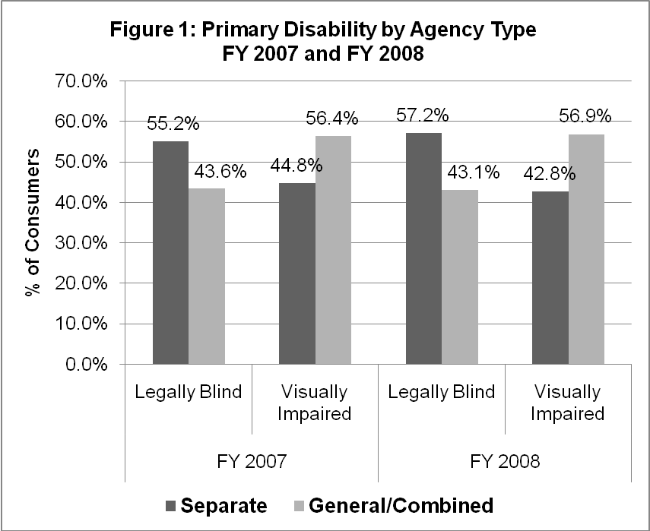

Race and ethnicity. A slightly smaller percentage of White non-Hispanic consumers were closed from Separate agencies (FY 2007, 62.5%; FY 2008, 60.0%) than in General/Combined agencies (FY 2007, 63.6%; FY 2008, 63.2%) in both fiscal years. A larger percentage of Hispanic consumers were closed in Separate agencies (FY 2007, 12.8%; FY 2008, 14.3%) than in General/Combined agencies (FY 2007, 9.0%; FY 2008, 9.4%). Other racial breakdowns in the two agency types were similar. Percentages of consumers by race/ethnic categories and agency type for FY 2007 and FY 2008 are reported in Table 2.

Table 2: Racial/Ethnic Percentages by Agency Type
 | FY 2007 |  | FY 2008
 | Separate | General/  Combined | Separate | General/  Combined
Race/Ethnicity
White, non-Hispanic | 62.5% | 63.6% | 60.0% | 63.2%
Black, non-Hispanic | 21.5% | 23.3% | 23.0% | 22.7%
American Indian/Alaska Native | 0.8% | 1.1% | 0.8% | 1.0%
Asian | 1.4% | 1.9% | 1.2% | 1.9%
Native Hawaiian/Pacific Islander | 0.2% | 0.7% | 0.1% | 1.1%
Hispanic of any Race | 12.8% | 9.0% | 14.3% | 9.4%
Multiple race/ethnicity | 0.7% | 0.5% | 0.6% | 0.8%

Gender. A slightly larger percentage of the total consumers closed from General/Combined agencies were female compared with consumers of Separate agencies. In FY 2007, 47.1% of legally blind consumers closed in the Separate agencies group were female, compared with 49.4% of legally blind consumers in General/Combined agencies. The pattern was maintained for legally blind consumers in FY 2008 with 46.5% females in Separate agencies compared to 50.2% female in General/Combined agencies. Percent female for legally blind and VI consumers by agency type are graphically shown in Figure 2.

Age. The mean age at application of legally blind consumers of Separate agencies was slightly less than consumers of General/Combined agencies. Conversely, the mean age of VI consumers of Separate agencies was slightly greater than consumers of General/Combined agencies. In FY 2007, the mean age at application for legally blind consumers of Separate agencies was 42.7 years compared with 45.8 years in General/Combined agencies. The pattern was maintained for legally blind females closed in FY 2008, with a mean application age of 42.2 years for Separate agencies compared to 46.0 years for General/Combined agencies. Mean ages for legally blind and VI consumers by agency type are graphically shown in Figure 3.
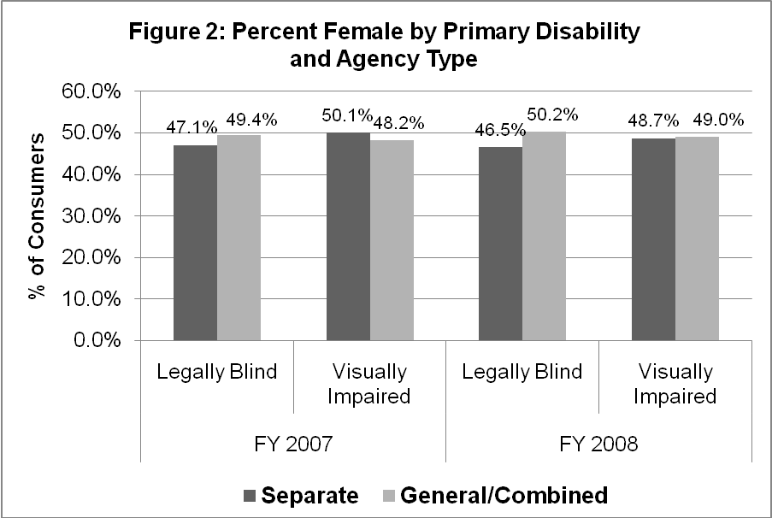

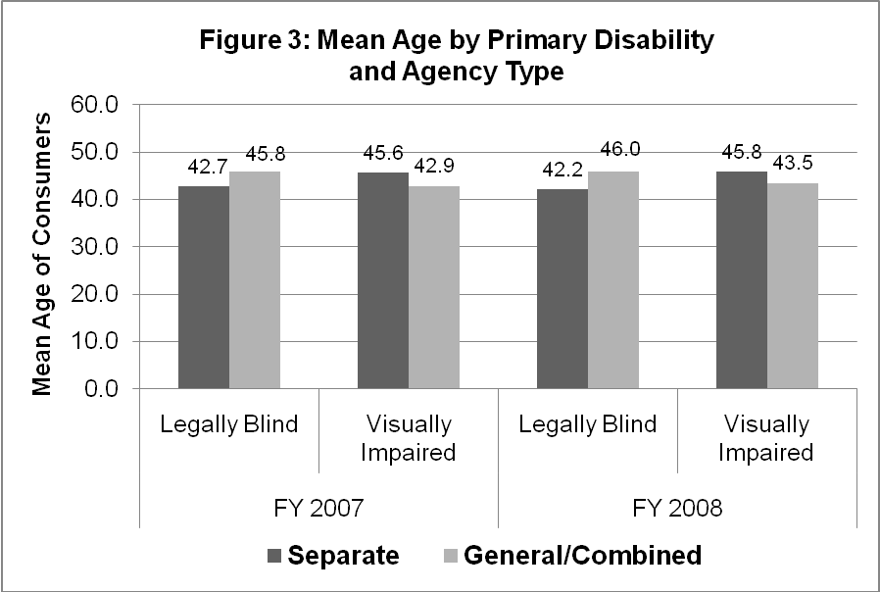
Education. Table 3 includes information on the educational levels of blind and VI consumers at application. In both FYs 2007 and 2008, a larger percentage of legally blind and VI consumers in Separate agencies did not have a high school diploma in comparison with legally blind and VI consumers in General/Combined agencies.

Table 3: Education at Application by Primary Disability
and Agency Type
 | Legally Blind |  | Visually Impaired
 | Separate | General/  Combined | Separate | General/  Combined
FY 2007
Less than High School Diploma | 26.1% | 21.8% | 28.7% | 22.6%
High School Diploma | 32.3% | 35.7% | 36.9% | 41.1%
Post-secondary, No Degree | 16.0% | 16.4% | 15.8% | 15.8%
Associate/Vocational Degree | 7.9% | 9.0% | 8.3% | 9.2%
Bachelors/Masters | 17.7% | 17.2% | 10.2% | 11.3%
FY 2008
Less than High School Diploma | 26.2% | 21.7% | 28.2% | 22.7%
High School Diploma | 32.5% | 36.0% | 38.5% | 40.2%
Post-secondary, No Degree | 15.4% | 17.7% | 14.7% | 15.9%
Associate/Vocational Degree | 8.2% | 9.3% | 8.3% | 9.4%
Bachelors/Masters | 17.7% | 15.3% | 10.2% | 11.8%

Public Support. Figure 4 shows the percentage of consumers receiving some type of public support at application. Types of public support include SSI, TANF, General Assistance, SSDI, VA, Workers' Compensation, or other public support. Approximately 60% of legally blind consumers and 30% of VI consumers received some type of public support at application. Percentages for the different categories of public support were similar for the two agency types.

Secondary disability. As shown in Figure 5, the percentages of legally blind consumers with secondary disabilities were similar for Separate and General/Combined agencies across the two fiscal years. Note this finding was not the same for VI consumers in that percentages of VI consumers with secondary disabilities in Separate agencies were substantially higher than percentages in General/Combined agencies. In FY 2007, 43.5% of VI consumers in Separate agencies had secondary disabilities, compared to 33.8% in General/Combined agencies. Similar differences were found in FY 2008: 44.5% of VI consumers had secondary disabilities in Separate agencies compared with 33.0% in General/Combined agencies.

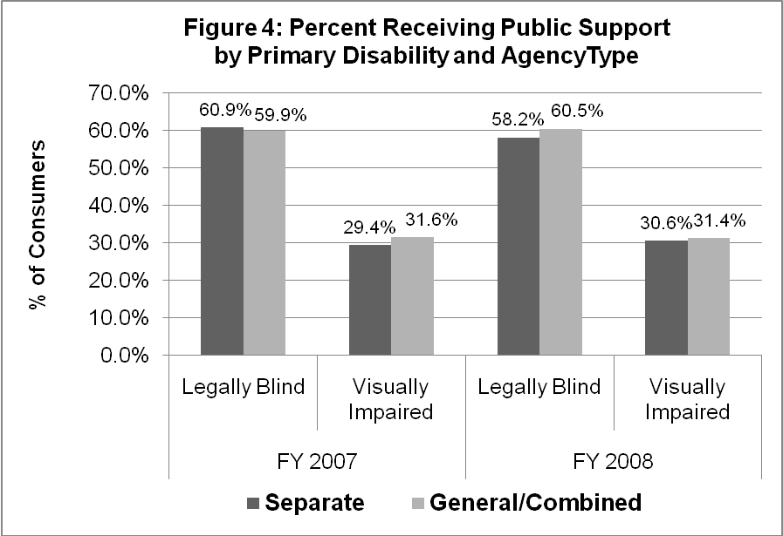

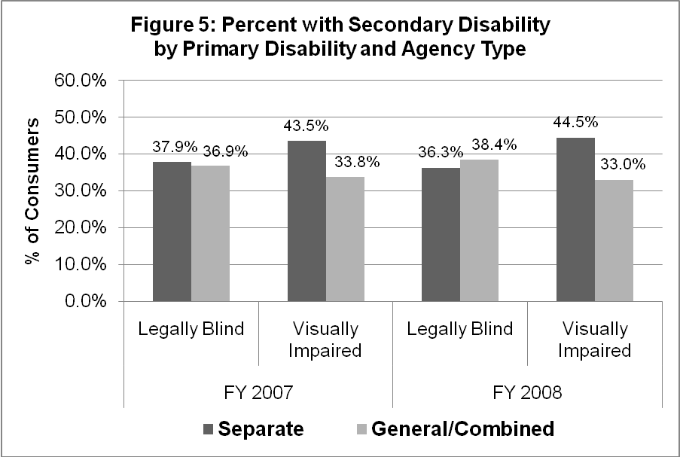
Research Question 2: What are the acceptance rates, average number of services received, average (median) cost of services, and duration of services for blind and VI consumers served in Separate agencies and General/Combined agencies?

Acceptance rates. Separate and General/Combined agencies accepted legally blind consumers at similar rates in FYs 2007 and 2008. General/Combined agencies accepted VI consumers at a higher rate than Separate agencies for both fiscal years (FY 2007, 82.1% vs. 72.5; FY 2008, 82.1% vs. 74.4%). To better understand reasons for lower acceptance rates, further analyses were conducted. These analyses indicated that differences were largely due to the approximately 50% of VI consumers closed "no disabling condition" in Separate agencies in comparison to the less than 15% of VI consumers closed for this reason in General/Combined agencies. This finding is consistent with policies common to many Separate agencies in which applicants with less severe visual impairments are not eligible for services and are referred to General VR agencies. Acceptance rates for blind and VI consumers by agency type are presented in Figure 6.

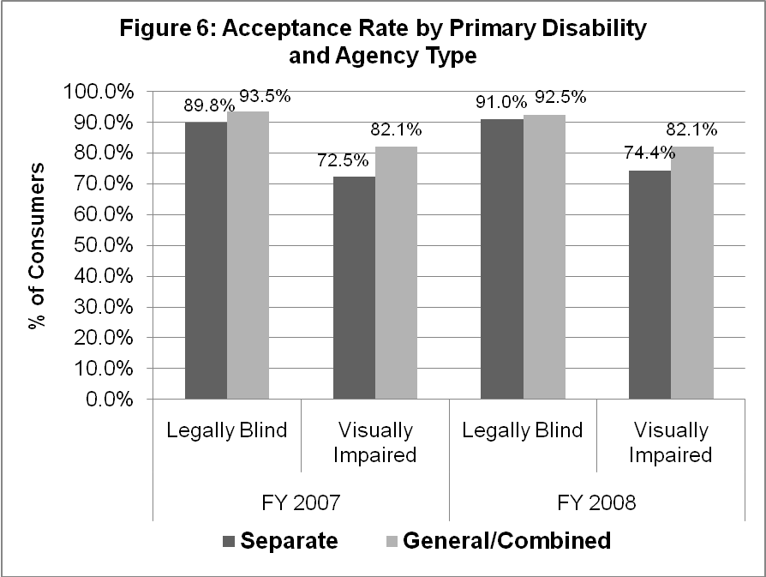

Number and cost of services. Table 5 includes service data on the subgroup of consumers who were accepted for VR, had a signed IPE, and received services. Mean number of services and median cost of services were similar for consumers in both types of agencies. Legally blind consumers averaged approximately five to six services and VI consumers averaged four to five services. Median cost of services was approximately $3,500 for legally blind consumers and $3,000 for VI consumers.

Time from IPE to closure. Table 5 also includes data on median days from IPE to case closure for the subgroup of consumers who were accepted for VR, had a signed IPE, and received services. For legally blind consumers, median days from IPE to closure was less if served in a Separate agency (FY 2007, 515 days; FY 2008, 511 days) than if served in a General/Combined agency (FY 2007, 556 days; FY 2008, 605 days). The pattern held for visually impaired consumers. In FY 2007, median days from IPE to closure was 359 for VI consumers served in Separate agencies compared with 433 days in General/Combined agencies. In FY 2008, median days for VI consumers was 413 in Separate agencies and 426 in General/Combined agencies.

Table 5: Service Variables by Primary Disability and Agency Type
 | Legally Blind |  | Visually Impaired
 | Separate | General/Combined | Separate | General/Combined
FY 2007
Mean Number of Services | 5.5 | 5.6 | 4.2 | 4.5
Median Cost of Services | $3,638 | $3,387 | $3,181 | $3,000
Median Days, IPE to Closure | 515 | 556 | 359 | 433
FY 2008
Mean Number of Services | 5.5 | 5.7 | 4.2 | 4.5
Median Cost of Services | $3,527 | $3,600 | $3,274 | $3,005
Median Days, IPE to Closure | 511 | 605 | 413 | 426

Research Question 3: What are the vocational rehabilitation outcomes (as measured by employment status at closure and competitive employment outcome at closure) for blind and VI consumers served in Separate and General/Combined agencies?

Employment status at closure. Table 5 includes data for the subgroup of consumers with an employment status at closure. In comparison to General/Combined agencies, Separate agencies closed higher percentages of legally blind and VI consumers in employment without supports in integrated settings and in self employment. Further, Separate agencies closed lower percentages in homemaker status than General/Combined agencies. For example in FY 2007, 20.1% of legally blind consumers were closed as homemakers in comparison to 39% in General/Combined agencies. The pattern held in FY 2008, with 15.9% of legally blind consumers closed as homemakers in Separate agencies in comparison to 40.8% in General/Combined agencies. Percentages for all employment categories by primary disability and agency type for FYs 2007 and 2008 are presented in table 5.

Table 5: Employment Status at Closure by Primary Disability and Agency Type
 | Legally Blind |  | Visually Impaired
 | Separate | Gen/Combined | Separate | Gen/Combined
 | (n=3,873) | (n=3,666) | (n=2,977) | (n=4,177)
FY 2007
Employment w/out supports | 65.3% | 52.3% | 78.6% | 79.0%
Extended Employment | 0.2% | 0.1% | 0.1% | 0.0%
Self-employment (except BEP) | 8.4% | 3.5% | 10.6% | 6.3%
BEP | 1.9% | 2.2% | 0.3% | 0.6%
Homemaker | 20.1% | 39.0% | 8.4% | 11.4%
Unpaid Family Worker | 0.3% | 0.1% | 0.7% | 0.3%
Employment with supports | 3.9% | 2.7% | 1.3% | 2.3%
Total | 100% | 100% | 100% | 100%
 | (n=3,521) | (n=3,884) | (n=2,719) | (n=4,198)
FY 2008
Employment w/out supports | 70.7% | 51.0% | 78.8% | 76.2%
Extended Employment | 0.3% | 0.1% | 0.1% | 0.0%
Self-employment (except BEP) | 7.5% | 3.6% | 12.0% | 8.0%
BEP | 2.1% | 2.0% | 0.5% | 0.3%
Homemaker | 15.9% | 40.8% | 7.2% | 12.7%
Unpaid Family Worker | 0.2% | 0.2% | 0.4% | 0.2%
Employment with supports | 3.2% | 2.1% | 1.1% | 2.5%
Total | 100% | 100% | 100% | 100%
Competitive employment. Individuals closed in employment with or without supports in integrated settings, self-employment, or BEP are coded competitively employed. Individuals closed Homemaker, Unpaid Family Worker, and Extended Employment are not coded competitively employed. Competitive employment is further defined in the Method section.
In FY 2007, 14,678 blind and VI consumers had competitive employment outcomes. Separate agencies reported 6,842 and General/Combined agencies reported 7,836 cases. In FY 2008, 14,304 consumers had competitive employment outcomes, with Separate agencies reporting 6,590 and General/Combined reporting 7,714 cases. In both fiscal years, Separate agencies, in comparison to General/Combined agencies, had a higher percentage of consumers with competitive employment outcomes (see Figure 7). For example in FY 2007, 77.5% of legally blind consumers were closed competitively in Separate agencies compared with 60.2% in General/Combined. This gap was larger in FY 2008: 82.8% of legally blind consumers were closed competitively in Separate agencies compared with 57.4% in General/Combined.

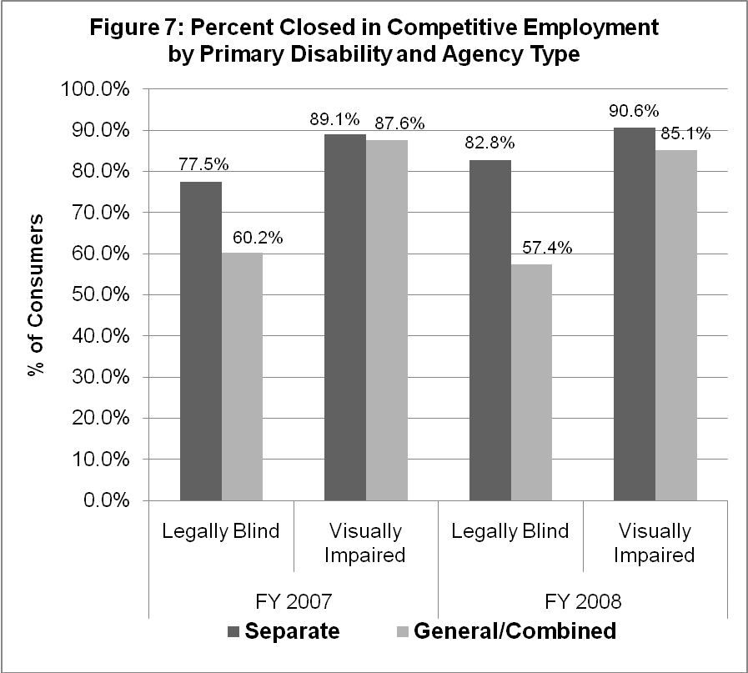
DISCUSSION

The purpose of this study was to reexamine the vocational rehabilitation experiences of consumers who are blind or visually impaired and how these experiences differ for persons served in Separate agencies and in General/Combined agencies. Consumers were categorized into two groups, Legally Blind and Other Visually Impaired, with the Legally Blind group having the least vision. FY 2007 and FY 2008 RSA-911 databases were used for all analyses. To identify longer term patterns of characteristics, services, and outcomes, attempts were made to compare findings from the current study with those from earlier investigations of RSA-911 databases.

Consumer Characteristics at Application

- Consumers of Separate agencies are similar to consumers of General/Combined agencies on several demographic characteristics (i.e., most race/ethnic categories, gender, receipt of public support).

- A higher percentage of applicants of Separate agencies identify as Hispanic.
  - FY 2007: 12.8% vs. 9.0%
  - FY 2008: 14.3% vs. 9.4%

- A higher percentage of applicants of Separate agencies have less than a high school diploma.
  - FY 2007: 26.1% vs. 21.8% (legally blind consumers)
28.7% vs. 22.6% (other VI consumers)
  - FY 2008: 26.2% vs. 21.7% (legally blind consumers)
28.2% vs. 22.7% (other VI consumers)

- Legally blind applicants tend to be 2-3 years younger in Separate agencies; VI applicants tend to be 2-3 years older in Separate agencies.

- A higher percentage of applicants of Separate agencies have more severe vision loss.
  - FY 2007: 55.2% vs. 43.6% are legally blind
  - FY 2008: 57.2% vs. 43.1% are legally blind

- Although the percentage of legally blind applicants with secondary disabilities in Separate agencies is similar to the percentages in General/Combined agencies, a higher percentage of visually impaired applicants in Separate agencies have secondary disabilities.
  - FY 2007: 43.5% vs. 33.8%
  - FY 2008: 44.5% vs. 33.0%

Patterns/trends. Results from analyses of demographic and disability characteristics are consistent with earlier findings that consumers of Separate agencies, compared to consumers of General/Combined agencies, have more severe vision loss, less education, have secondary disabilities (VI group), and identify as Hispanic (Cavenaugh & Pierce, 1998; Cavenaugh, 1999; Cavenaugh et al., 2000; Kirchner & Peterson, 1982). (Note that several states with large Hispanic populations also have Separate VR agencies.) Unlike previous studies, current analyses found only slight differences on gender, age, and self-support variables.

Services

Acceptance Rates

- General/Combined agencies accept legally blind consumers at similar rates as Separate agencies but accept VI consumers at considerably higher rates.

Patterns/trends. These findings are also consistent with earlier studies (Cavenaugh & Pierce, 1998; Cavenaugh, 1999; Cavenaugh et al., 2000; JWK, 1981, Kirchner & Peterson, 1982). Because Separate agencies may restrict services to consumers with more severe visual impairments, we expected and found a high percentage of VI consumers closed for reason of “no disabling condition” in Separate agencies. For example in FY 2007, 49.7% of VI consumers in Separate agencies were closed “no disabling condition” compared with only 11.4% of VI consumers closed for this reason from General/Combined agencies.

Number of Services
- Separate and General/Combined agencies provide essentially the same number of services to both Legally Blind and VI consumers.
Patterns/trends. Earlier investigations found that legally blind consumers in Separate agencies received only slightly more services (≈0.5) than consumers of General/Combined agencies and that VI consumers received about the same number of services as those in General/Combined agencies (Cavenaugh & Pierce, 1998; Cavenaugh et al., 2000).

Cost of Services

- Consistent with findings regarding number of services, median cost of services was similar in Separate and General/Combined agencies.

Patterns/trends. Early investigations using mean cost of services for comparisons found that cost of services is higher in Separate agencies than in General agencies. For example, JWK (1981), Cavenaugh & Pierce (1988), and Cavenaugh et al. (2000) reported that Separate agencies spend more for services to legally blind consumers than do General agencies. They also reported that Separate agencies spend less, or the same, for services to the VI consumers. NAC (1997) reported the average cost of services was approximately $600 more in Separate agencies than in General agencies.

Time from IPE to Closure

- Median days from IPE to closure was greater for legally blind and visually impaired consumers served in General/Combined agencies.

Patterns/trends. Earlier studies used mean averages for comparisons and generally found no differences in Separate and General/Combined agencies in the amount of time spent in services (NAC, 1997) or slight differences in time (Cavenaugh & Pierce, 1998; Cavenaugh et al., 2000).

Consumer Outcomes

Employment Status at Closure

- Separate agencies close a higher percentage of legally blind consumers in employment without supports in integrated settings.
  - FY 2007: 65.3% vs. 52.3%
  - FY 2008: 70.7% vs. 51.0%

- Separate agencies close higher percentages of legally blind consumers in self-employment.
  - FY 2007: 8.4% vs. 3.5%
  - FY 2008: 7.5% vs. 3.6%

- Separate agencies close a lower percentage as homemakers.
  - FY 2007: 20.1% vs. 39.0%
  - FY 2008: 15.9% vs. 40.8%

Patterns/trends. Current findings are consistent with analyses of RSA-911 databases from the 1980s and 1990s indicating that Separate agencies, compared with General/Combined agencies, close a higher percentage of consumers in employment in integrated settings and in self-employment (Cavenaugh & Pierce, 1998; Cavenaugh et al., 2000; NAC, 1997). Earlier analyses of databases from the 1970s showed an opposite trend (Kirchner & Peterson, 1982; JWK, 1981).

Competitive Employment

- Separate agencies close a larger percent of legally blind consumers in competitive employment.
  - FY 2007: 77.5% vs. 60.2%
  - FY 2008: 82.8% vs. 57.4%

- Although differences are small, Separate agencies close a larger percent of VI consumers in competitive employment.
  - FY 2007: 89.1% vs. 87.6%
  - FY 2008: 90.6% vs. 85.1%

Patterns/trends. Current findings are consistent with previous investigations indicating that Separate agencies, compared with General/Combined agencies, close a higher percentage of consumers in competitive employment (Cavenaugh & Pierce, 1998; Cavenaugh et al., 2000; NAC, 1997). Note that the Competitive Employment variable is somewhat different from competitive variables used in previous investigations in that with the current variable, individuals must be compensated at or above the minimum wage.

Limitations

Consumer characteristics, diversity of service delivery within each agency type, and other environmental forces combine to form complex interactions influencing VR outcomes. These interactions are best understood in a multivariate research context. Further, only data contained in the RSA-911 reports were considered for analyses. This restriction resulted in the exclusion of, or lack of control for, other variables that might have influenced VR services and outcome. For example, quality of agency personnel, local/regional economic conditions, and opportunities for specialized itinerant and center-based services are but a few of the variables which combine to forge a unique VR experience for each consumer.

CONCLUSIONS

This study uses a descriptive approach to investigate demographic and disability characteristics, services, and outcomes of consumers who are blind or visually impaired served in state-federal VR programs. In contrasting key measures reported by Separate blindness agencies and General/Combined agencies, our findings support the following major conclusions:

- Separate blindness agencies continue to serve a higher percentage of consumers with demographic/disability characteristics associated with lower labor force participation rates.
  - Applicants have more severe visual impairments (blindness vs. other visual impairments).
  - Blind and VI applicants have lower educational levels (not high school graduates).
  - VI applicants are more likely to have secondary disabilities.

- Separate and General/Combined agencies provide similar number of services to blind and VI consumers at similar costs.

- Separate blindness agencies continue to close a higher percentage of legally blind consumers into competitive employment.
  - Separate blindness agencies close a higher percentage of legally blind consumers into employment without supports in integrated work settings.
  - Separate blindness agencies close a higher percentage of legally blind consumers into self-employment.
  - Separate blindness agencies close a lower percentage of legally blind consumers as homemakers.

Findings are based on analyses of two RSA-911 databases: FY 2007 and FY 2008 RSA-911. Comparisons are made with findings from analyses of 1996, 1994, 1989, 1977, and 1971 RSA data. Our conclusions are corroborated with previous studies which also reported that Separate blindness agencies serve consumers who are more likely to be legally blind and to have less education (Cavenaugh & Pierce, 1998; Cavenaugh, 1999; Cavenaugh et al., 2000; Kirchner & Peterson, 1982).Findings are also consistent with earlier studies indicating that consumers in Separate agencies with less severe visual impairments (VI but not legally blind) are more likely than those in General/Combined agencies to have secondary disabilities (Cavenaugh & Pierce; Cavenaugh et al.; NAC, 1997).
Although analyses of 1971 and 1977 RSA data indicated that Separate blindness agencies close more homemakers (JWK, 1981; Kirchner & Peterson), our finding that Separate blindness agencies close a lower percentage of homemakers is consistent with analyses of more recent RSA data. Most importantly, our findings that Separate agencies close larger percentages of individuals in competitive employment (for example, employment in integrated settings, self-employment) is consistent with analyses of RSA-911 data spanning three decades (Cavenaugh & Pierce; Cavenaugh et al.; NAC).

With the foregoing conclusions in mind, it is important to note that Separate blindness agencies continue to exist in a political climate hostile to categorical service delivery models. Given the highly political nature of the separate versus combined agency debate, it is conceivable that current public policy supporting specialized disability programs could be reversed without regard to its negative impact on the rehabilitation outcomes of blind persons. Findings from this analysis of FYs 2007 and 2008 RSA-911 data (the most recent available) continue to support the efficacy of Separate agencies. With national unemployment rates at around 10%, rehabilitation professionals and policy makers must focus on increasing employment opportunities for consumers who are blind or visually impaired and be wary of any policy changes that would likely lead to increased unemployment for this group.

REFERENCES

Cavenaugh, B. S. (1999). Relationship of agency structure and client characteristics to rehabilitation services and outcomes for consumers who are blind (Monograph). Mississippi State University, Rehabilitation Research and Training Center on Blindness and Low Vision.

Cavenaugh, B. S., & Pierce, S. J. (1998). Characteristics, services, and outcomes of rehabilitation consumers who are blind or visually impaired served in separate and general agencies (Technical Report). Mississippi State: Mississippi State University, Rehabilitation Research and Training Center on Blindness and Low Vision.

Cavenaugh, B., Giesen, J., & Pierce, S. (2000). Rehabilitation of visually impaired persons in separate and general agencies. Journal of Visual Impairment and Blindness, 94 (3), 133-145.

JWK International Corporation. (1981). Evaluation of RSA programs for blind and visually handicapped persons. Annandale, VA: Author.

Kirchner, C. (1982). Effects of state agency structures on VR services for blind and visually impaired persons: Part 1. Journal of Visual Impairment and Blindness, 76(1), 31-33.

Kirchner, C., & Peterson, R. (1982). Effects of state agency structures on VR services for blind and visually impaired persons: Part II. Journal of Visual Impairment and Blindness, 76(2), 73-78.

Management Services Associates. (1975). Study of the organization, service delivery, evaluation of programs to effectively serve the blind. Austin, TX: Author.

National Accreditation Council for Agencies Serving the Blind and Visually Handicapped. (1997). Outcomes achieved by consumers with vision loss served by specialized and general state VR agencies, FY 1994. New York: Author.
APPENDIX

Listing of States with Separate VR Agencies for the Blind

Arkansas
Connecticut
Delaware
Florida
Idaho
Iowa
Kentucky
Maine
Massachusetts
Michigan
Minnesota
Mississippi
Missouri
Nebraska
New Jersey
New Mexico
New York
North Carolina
Oregon
South Carolina
South Dakota
Texas
Vermont
Virginia
Washington

